GYM API Response Documentation

1. VFT_GYM_API_V2.0 (Root Folder)
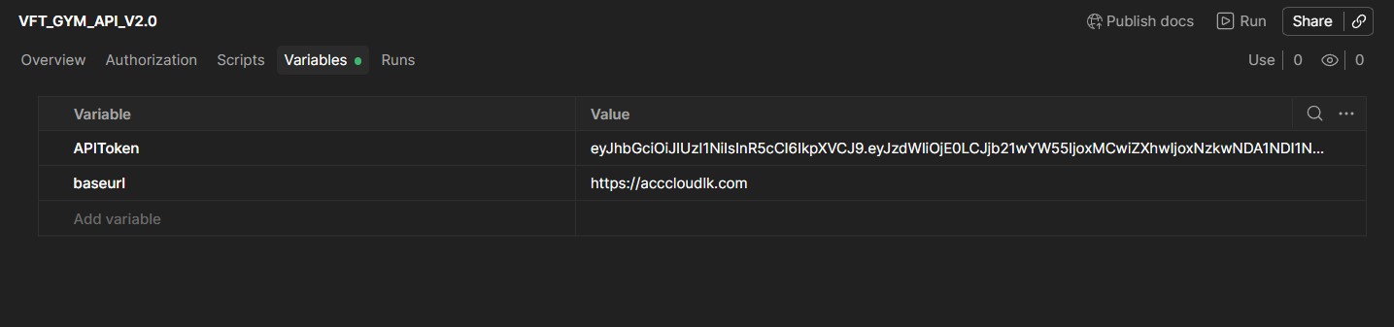

2. Authentication
2.1 Sign in (POST)
API = {{baseurl}}/api/user/
Output
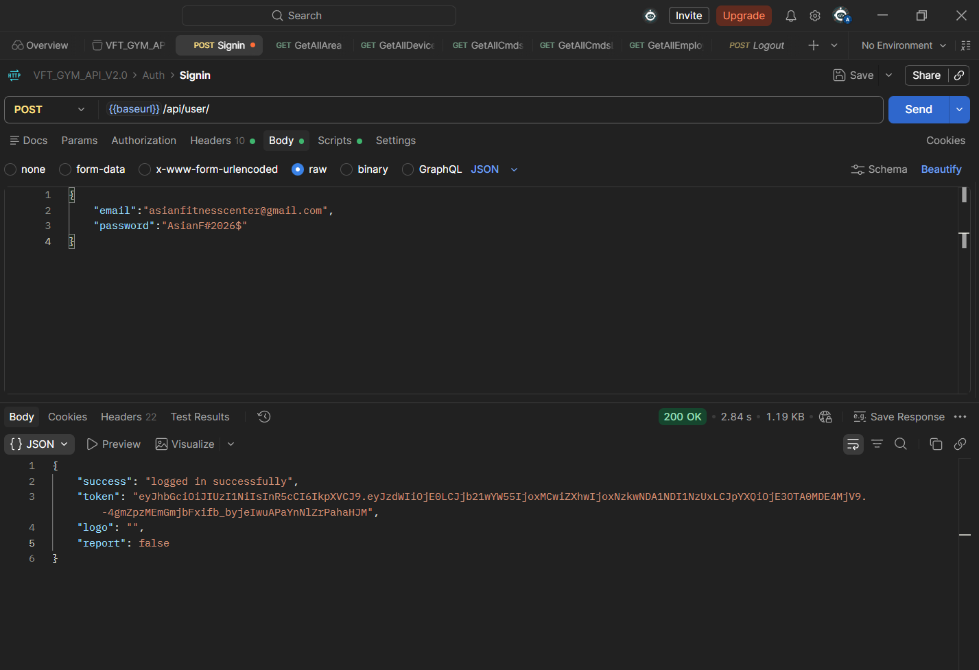

2.2 Logout (POST)
API = {{baseurl}}/api/user/logout

Output:
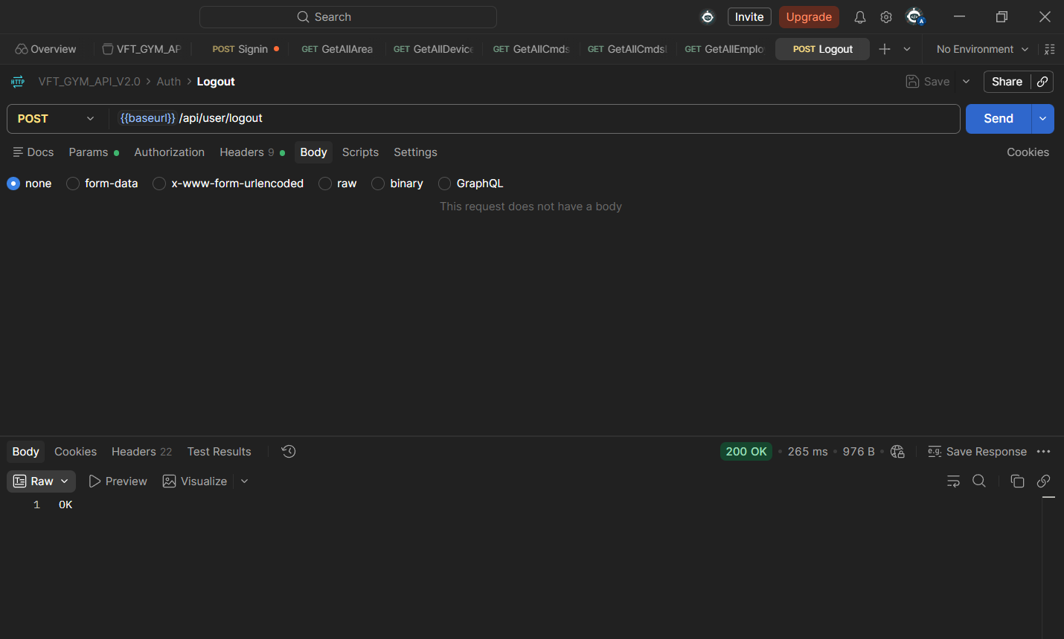

3. Area Management

3.1 Add Area (POST)
API = {{baseurl}}/api/area
Output:
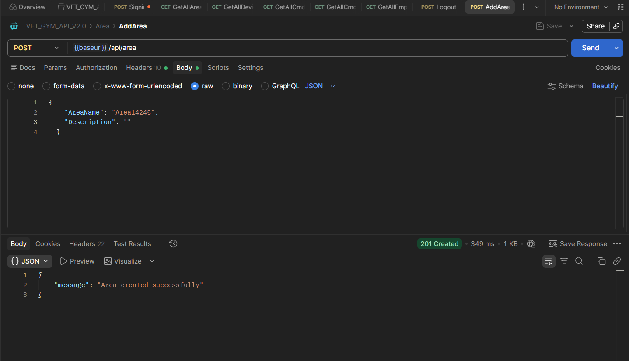

3.2 Get all area (GET)
API = {{baseurl}}/api/area
Output :
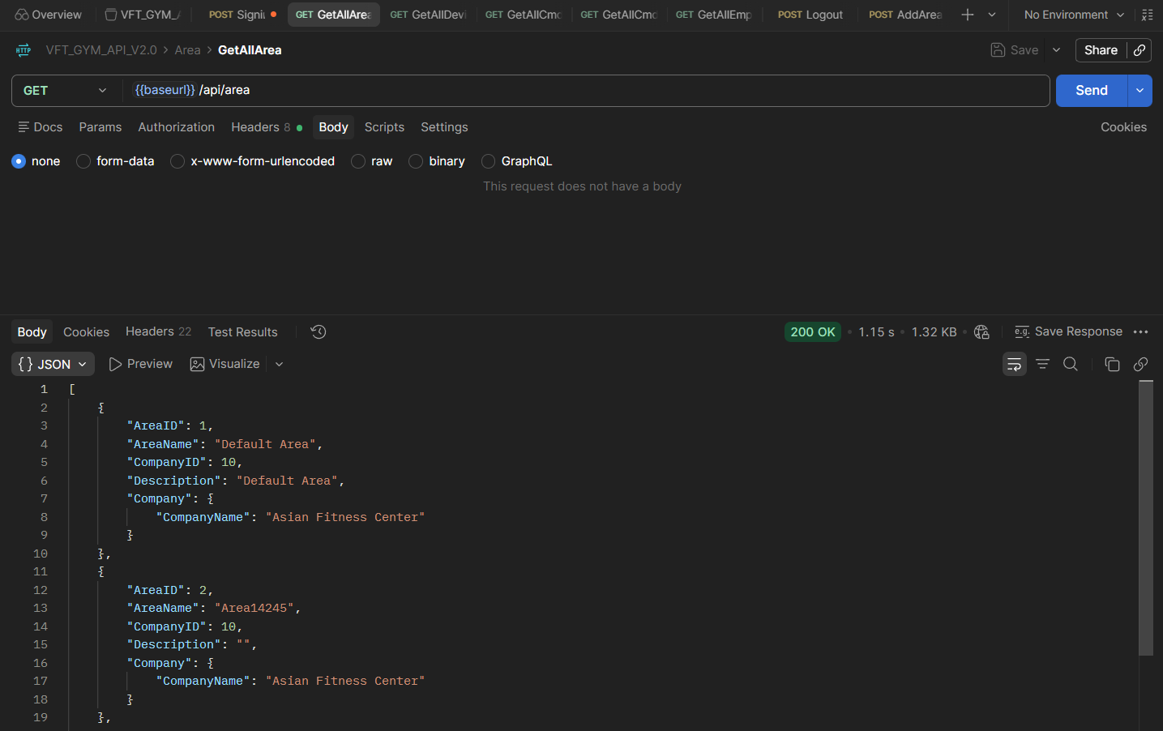

3.3 Update Area (PUT)
API = {{baseurl}}/api/area/1
Output:
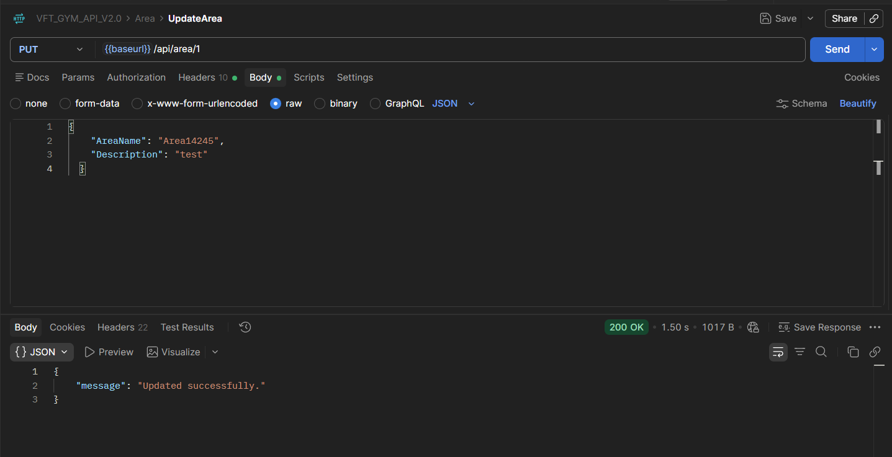

4. Device management

4.1 Get all device (GET)
API = {{baseurl}}/api/device
Output:
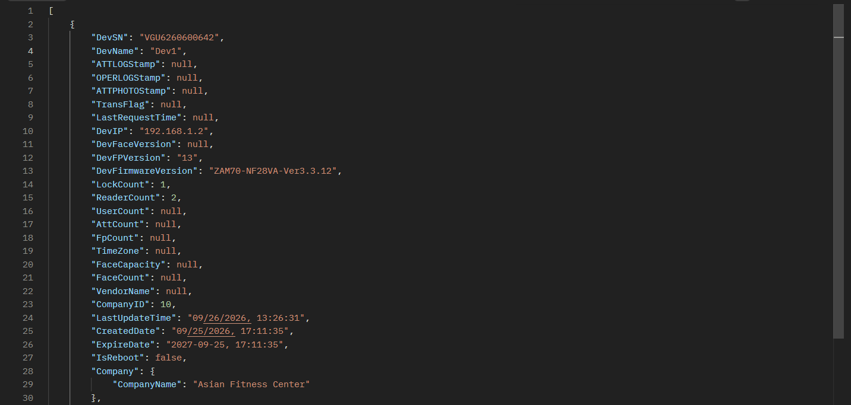
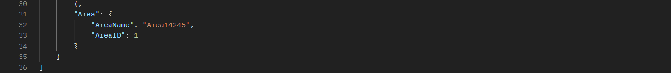

4.2 Update Device (PUT)
API = {{baseurl}}/api/device/QEM1253800017
Output :
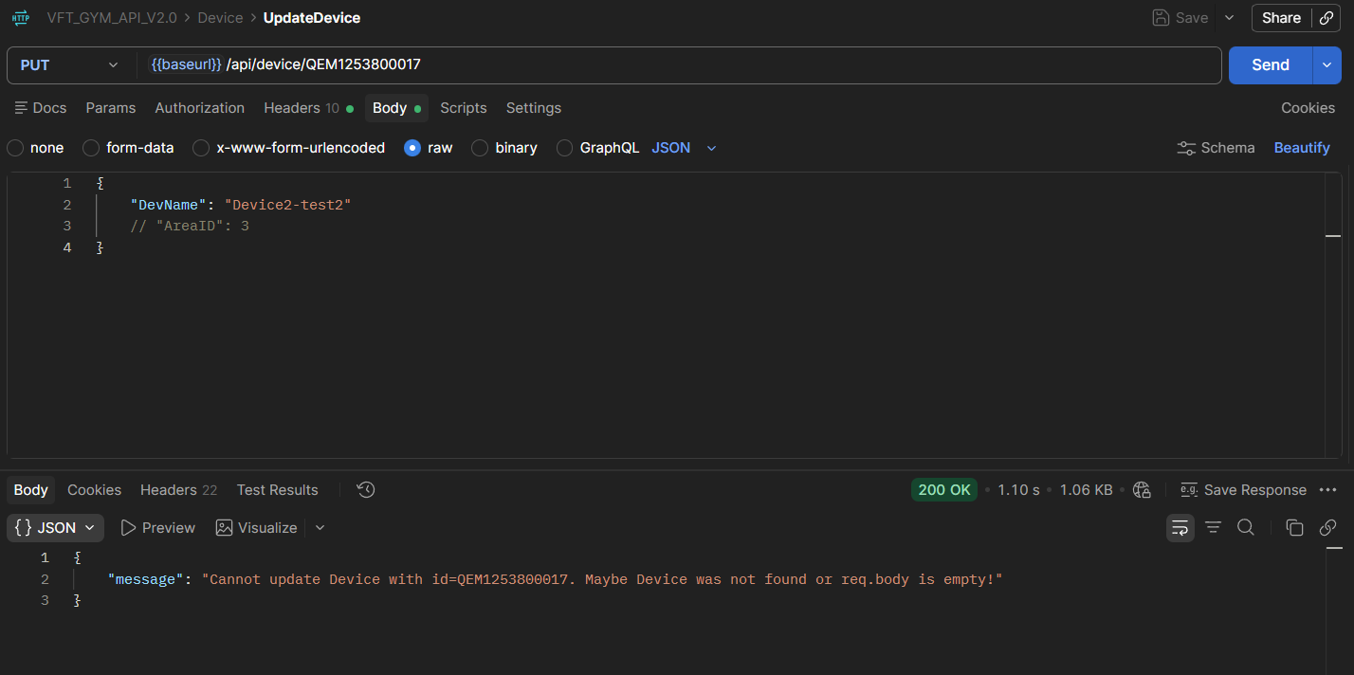

5. Employee management

5.1 Add Employee (POST)
API = {{baseurl}}/api/template/add
Output:
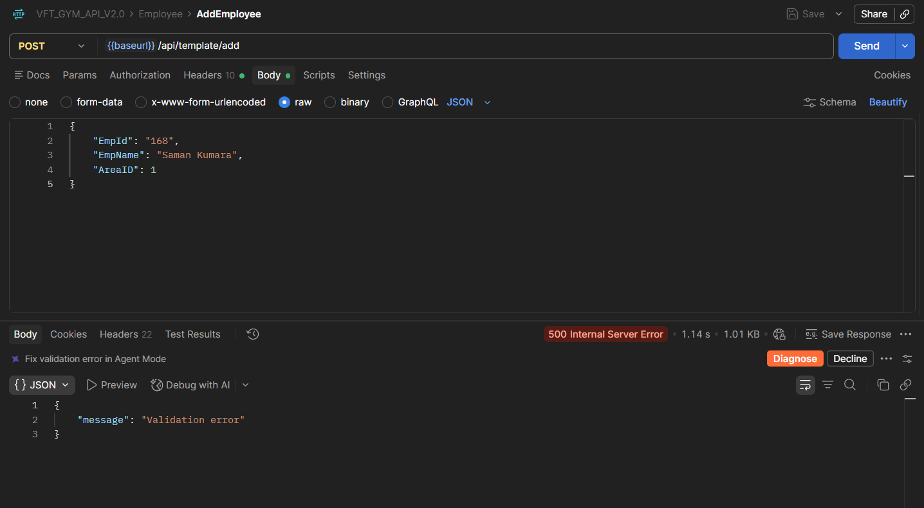
* I didn't try to create a new employee

5.2 Get all employees(GET)
API = {{baseurl}}/api/template
Output:
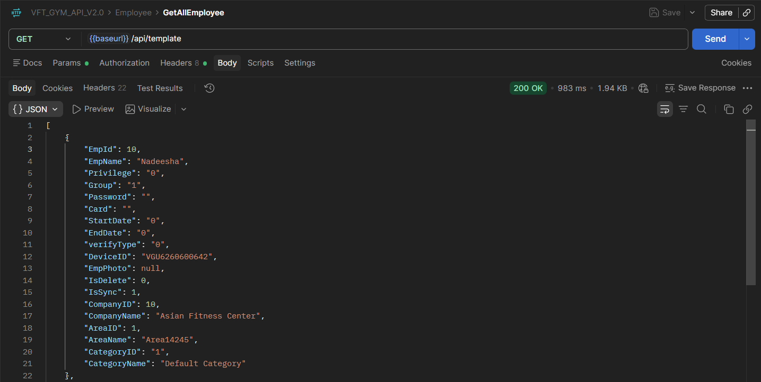

5.3 Update Employee (PUT)
API = {{baseurl}}/api/template/edit/166
Output:
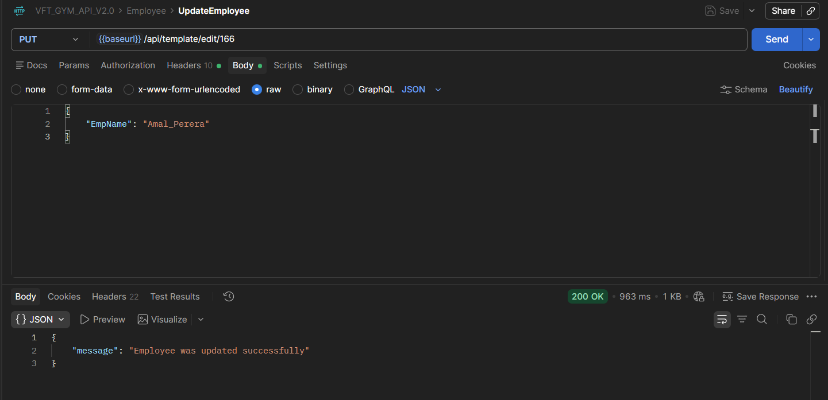

5.4 Delete Employee(DELETE)
API = {{baseurl}}/api/template/166
Output:
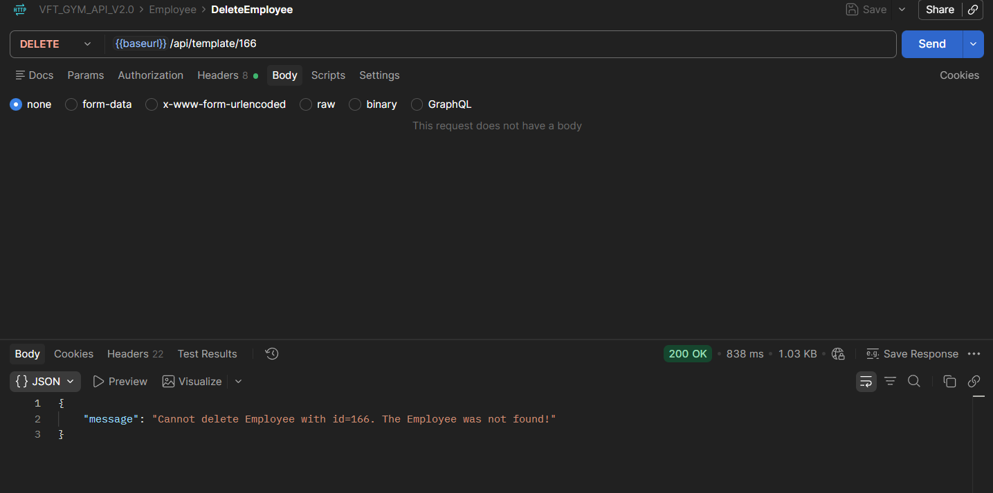
* I didn’t Try to delete existing member

5.5 Delete from all devices (DELETE)
API = {{baseurl}}/api/template/fromdev/166
Output :
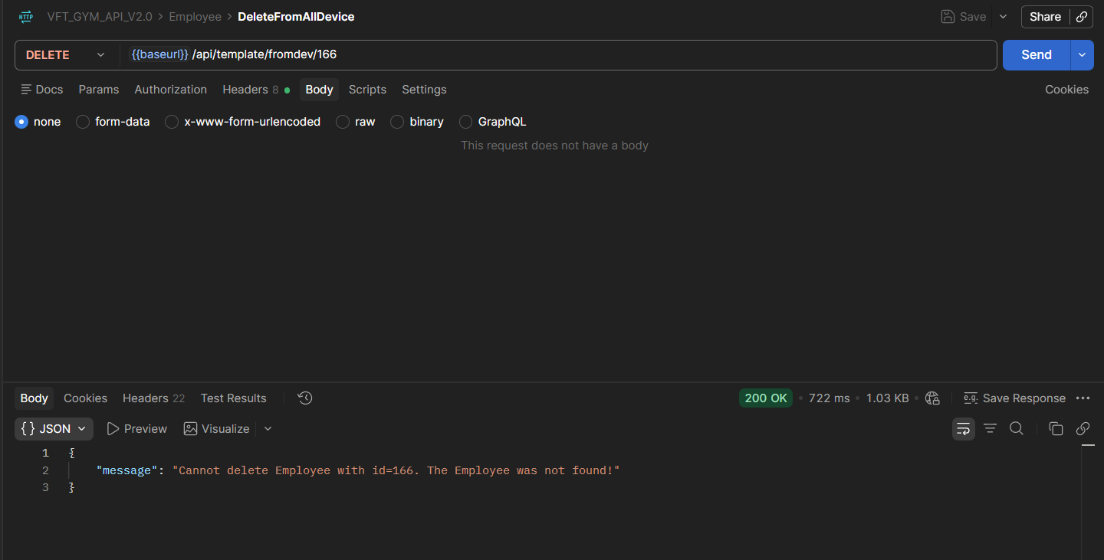
* I didn’t Try to delete existing member

